New Roots for Restoration Biology Integration Institute
Research Experiences for Undergraduates at Kansas University
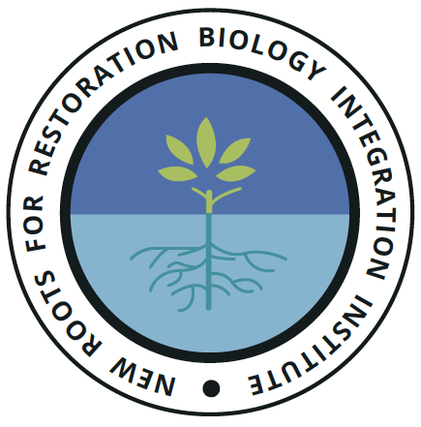
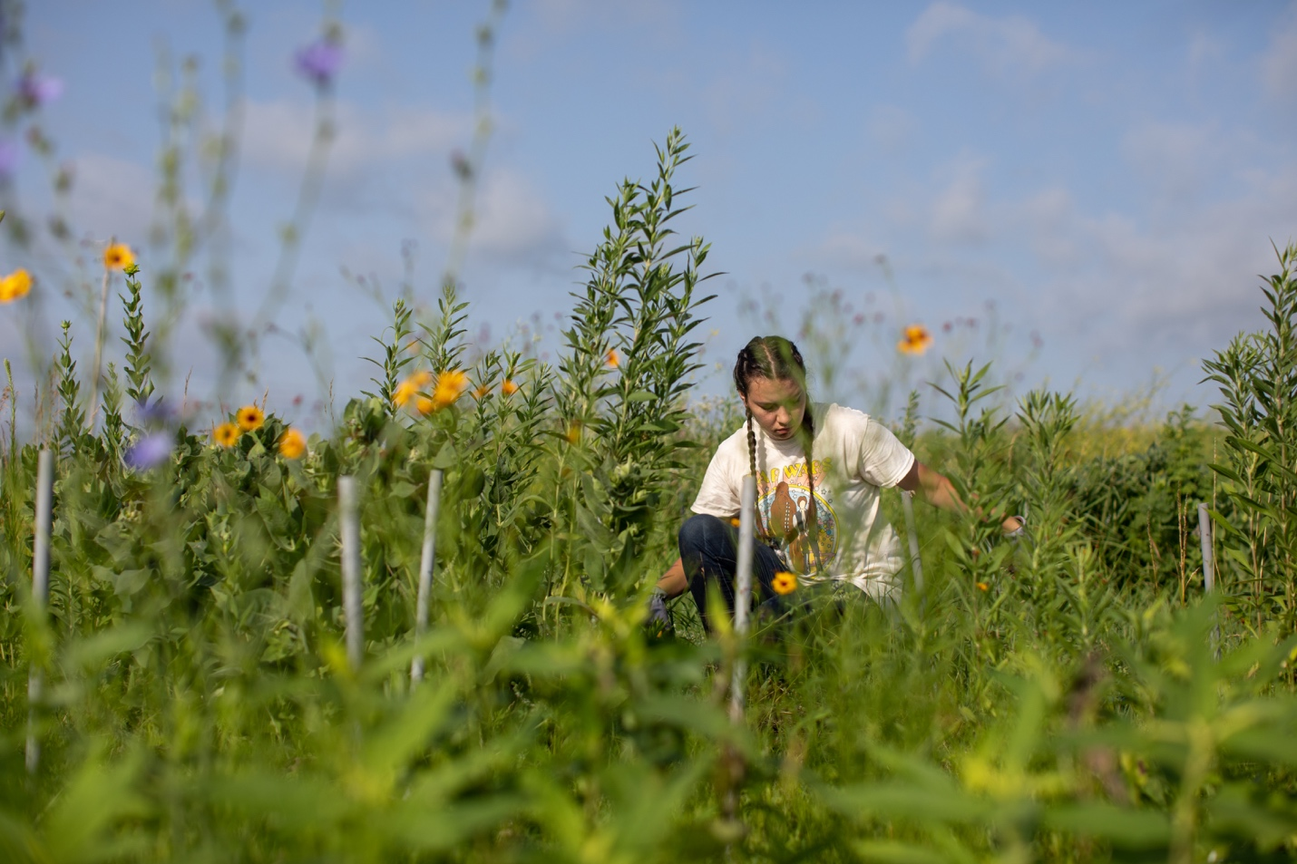

The University of Kansas Department of Ecology and Evolutionary Biology/Kansas Biological Survey is recruiting students to participate in Research Experiences for Undergraduates (REU) opportunity in Summer 2022. The REU opportunities are part of the New Roots for Restoration Biology Integration Institute, a National Science Foundation funded initiative whose goal is to advance restoration of natural and agricultural ecosystems through enhanced understanding of how plant roots influence communities and the soil ecosphere. REU participants working at the University of Kansas will conduct research (described below), participate in the broader institute through in-person and virtual meetings, and will join a near-peer mentoring scheme in which they work closely with high school students, graduate students, and professors to achieve research, training, and diversifying goals.

Location and time frame: This REU opportunity takes place at the University of Kansas in Lawrence, KS and runs for 10 weeks from June 6 through August 12.

Eligibility: Applicants must be enrolled in an undergraduate degree program. Students who have already graduated with a four year degree are not eligible. Applicants must be U.S. Citizens or permanent residents.

Benefits: REU interns receive $6000 salary, food and lodging.

To apply: https://forms.gle/rFmiz1zckfpzMLzY6
Submissions due March 1, 2022 and selections will be made by March 15th.

Description of mentors and projects at KU:

Mentor Dr. Maggie Wagner, Assistant Scientist, Kansas Biological Survey, Assistant Professor, Ecology and Evolutionary Biology. Research in Maggie's lab focuses on how plants' genes shape the composition and function of plant-associated microbiomes. Maggie’s lab also investigates how microbial symbionts act as part of the environment to influence their plant host's phenotype, health, and fitness.
Students will conduct experiments to investigate how genetic diversity within a plant species affects the interactions with root-associated microbes. Most projects will focus on Eastern gamagrass (Tripsacum dactyloides), a wild perennial relative of corn. Potential projects include comparing the effects of different soil microbiomes on root and shoot characteristics; and measuring the abundance and metabolic activity of microbes colonizing the roots of diverse Eastern gamagrass genotypes.

Mentor Dr. Jim Bever, Senior Scientist, Kansas Biological Survey, Foundation Distinguished Professor of Ecology and Evolutionary Biology. Research in Jim’s lab has found that the interactions of plants and soil organisms have a strong influence on the diversity and productivity of plant communities. Students will work at the intersection of plant roots and the soil microbiome to test the potential interdependencies between plants and soil microbes in determining ecosystem functions. Students will have the option of working on a variety of projects, and we will match the research question to the interests of individual students. The potential projects include tests of the influence of mycorrhizal fungi on plant root architecture, tests of trade-offs of plant root architecture and responsiveness to mycorrhizal fungi, tests of plant soil feedback in prairie plants, and tests of plant preferential allocation to root symbionts.

